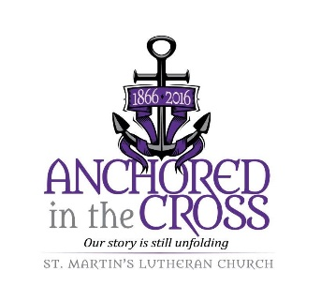

St. Martin Lutheran Church
Youth Ministry Positions
Two Position Postings – March 11, 2022

St. Martin Lutheran Church (SMLC) of Archbold, Ohio is excited to announce the creation of two new positions in its Youth Ministry Network. The ideal candidate for each position will be a motivated self-starter who can creatively lead church youth in their spiritual development, provide safe social activities and uplift service and mission work. Although it is not required that candidates be members of SMLC, a regular church presence and participation in the life of the church is expected. Each position is part time with the ability to have a flexible schedule.

**One candidate may apply for and fill both positions creating one full-time position. Appropriate benefits would then be made available.**

The two positions are: Youth Network Coordinator and Youth Team Leader. Submission details for each follow:

Submit Cover Letter and Resume to:
St. Martin Lutheran Church
Attn: Stan Schmidt
203 S. Defiance St.
Archbold, Ohio 43502

or email Stan Schmidt: spdjaaas1@hotmail.com
Deadline:
June 30, 2022

St. Martin Lutheran Church is an Equal Opportunity Employer.

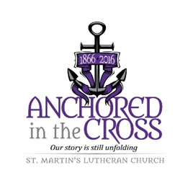
St. Martin Lutheran Church
Youth Network Coordinator – Position 1
Position Posting – March 11, 2022

Position Description:
St. Martin Lutheran Church is committed to building strong relationships with youth through open communication; participation in youth activities; recognizing and supporting youth in their activities outside of the church. The Youth Network Coordinator will oversee and coordinate a faith-based social and service program for youth in Grades 5-12. Job functions include:
- Train and oversee Youth Ministry Team leader and volunteers through routine meetings and collaboration
- Develop programming for FROGS (Fully Relying on God – Grades 5-8) and Luther League (Grades 9-12) providing year-round consistent activities that balance religious growth, social connections and service activities
- Coordinate activities for Luther League Youth Gathering with Youth Team Leader
- Develop outreach programs with youth team leader for those who do not routinely participate
- Have an active, regular presence in Sunday Morning worship, defined as being a visible part of the worship life of the church. Candidate need not be a member, but regular worship participation is expected.
- Regular communication with parents of all youth, and with the Congregation about the youth program
- Submission and implementation of budget for youth program; with monthly reporting to the Church Council
- Participate in a professional continuing education or personal development
- Coordinate graduate care packages for the college students of SMLC
- Coordinate recognition and gifts with team leader for all the graduating high school students of SMLC
- Be the point person for activities related to summer Vacation Bible School working with the VBS Team Leader
Qualifications:
The Youth Network Coordinator will be a Christian with a strong commitment to following Jesus Christ and making Disciples of Christ; have the ability to relate to people of all ages and have a passion for assisting youth to grow in faith; be able to maintain confidentiality and appropriate boundaries; exhibit organization, leadership, excellent communication skills, and be able to appropriately use social media to support youth ministry. Additional qualifications include:
- Experience in leadership role with students with experience in youth ministry preferred
- High School graduate
- Must possess a valid driver’s license and be insurable
- Must pass a criminal background check
Additional information and Benefits:
The Youth Network Coordinator position is a salaried position, averaging 10-20 hours per week, and will be supervised by the Pastor, Deacon and other parties deemed necessary by the Church Council. The church will provide a budget for youth ministry which can be accessed for activities and the cost of continuing education.
Compensation:
Salary is negotiable, to be paid on a semi-monthly salary schedule.
Location
The primary work location for this position will be at St. Martin Lutheran Church. Execution of duties will require travel in the local community and surrounding area. Training and youth gatherings will require more extensive travel.

St. Martin Lutheran Church
Youth Team Leader – Position 2
Position Posting – March 11, 2022

Position Description:
St. Martin Lutheran Church is committed to building strong relationships with youth through open communication; participation in youth activities; recognizing and supporting youth in their activities outside of the church. The Youth Team Leader will oversee and lead a faith-based social and service program for youth in Grades 5-12. Job functions include:
- Monitor and provide direction to volunteers under the supervision of the Youth Network Coordinator
- Provide input to Youth Network Coordinator for developing activities for the youth
- Implement programming activities
- Lead Luther League at Youth Gathering
- Regular communication with parents of all youth, and the Congregation about the youth program
- Maintain attendance and participation records
- Have an active, regular presence in Sunday Morning worship, defined as being a visible part of the worship life of the church. Candidate need not be a member, but regular worship participation is expected.
- Participate in a professional continuing education or personal development
- Coordinate recognition and gifts with Youth Network Coordinator for SMLC graduating high school students
Qualifications:
The Youth Team Leader will be a Christian with a strong commitment to following Jesus Christ and making Disciples of Christ; have the ability to relate to people of all ages and have a passion for assisting youth to grow in faith; be able to maintain confidentiality and appropriate boundaries; exhibit organization, leadership, excellent communication skills, and be able to appropriately use social media to support youth ministry. Additional qualifications include:
- Experience in leadership role with students with experience in youth ministry preferred
- High School graduate
- Must possess a valid driver’s license and be insurable
- Must pass a criminal background check
Additional information and Benefits:
The Youth Team Leader position is a salaried position, averaging 10-20 hours per week, and will be supervised by the Youth Network Coordinator. The church will provide a budget for youth ministry which can be accessed for activities and the cost of continuing education.
Compensation:
Salary is negotiable, to be paid on a semi-monthly salary schedule.
Location
The primary work location for this position will be at St. Martin Lutheran Church. Execution of duties will require travel in the local community and surrounding area. Training and youth gatherings will require more extensive travel.

